**Animals**

|  |  |  |  |  |
| --- | --- | --- | --- | --- |
| Animals | Accuratezza massima (%) e modello | | | |
|  | | **15 features** | **10 features** | **5 features** |
| Valenza 2 cat. | | 67,1 (SVM) | 64,5 (SVM, Ensemble) | 69,1 (SVM) |
| *non normalized* | | *65,1 (SVM)* |  |  |
| Valenza 3 cat. | | 59,9(KNN) | 58,6(SVM) | 55,9(SVM) |
| Arousal 2 cat. | | 67,8 (Ensemble) | 67,8 (SVM, Log. Regr., …) | 63,8 (Ensemble) |
| Arousal 3 cat. | | 54,6 (SVM) | 55,9 (SVM) | 57,9 (SVM) |

**Valence: 2 categorie**

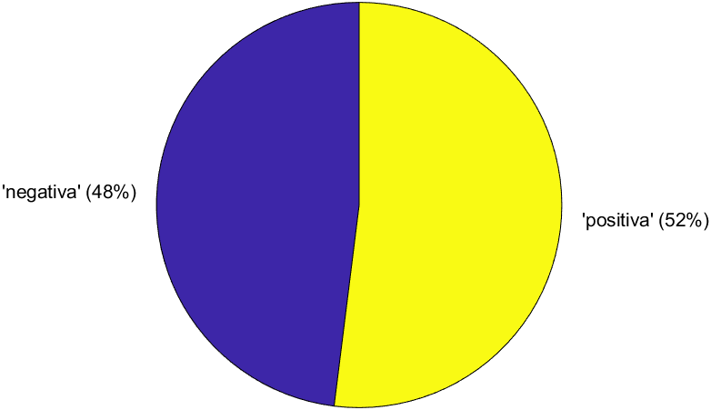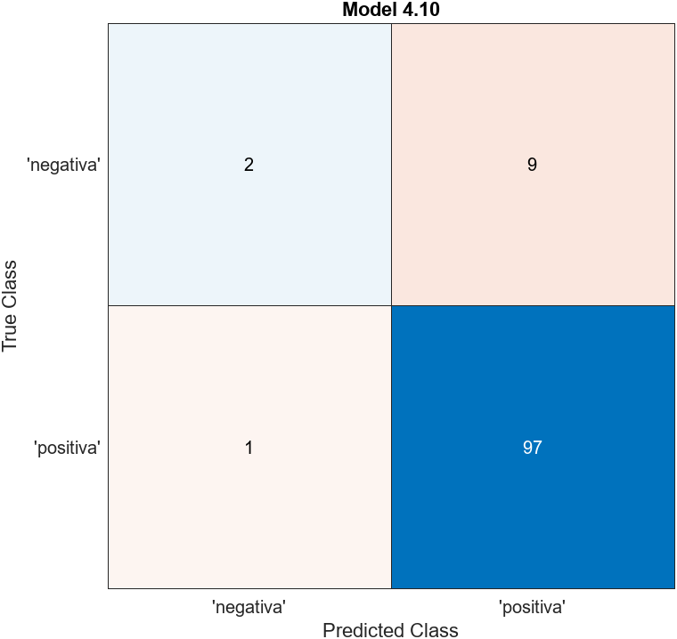

**Feature ranking (ANOVA)**

1. SizeInBytes 4.9376
2. SubbandEntropy 3.9416
3. Colorfulness 3.4620
4. FeatureCongestion 1.3561
5. SFresidual 0.9710
6. SF768_384 0.9080
7. AverageLuminosity 0.7618
8. SF12_6 0.7379
9. SF24_12 0.6816
10. Contrast 0.5959
11. SF6_3 0.3788
12. SF96_48 0.3619
13. SF192_96 0.2836
14. SF384_192 0.1868
15. SF48_24 0.1036

**Valence: 3 categorie**

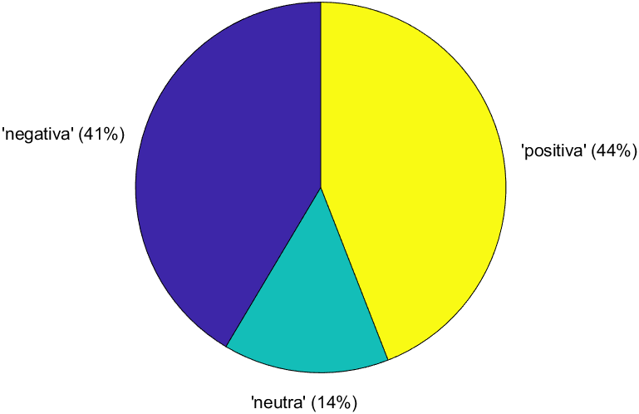 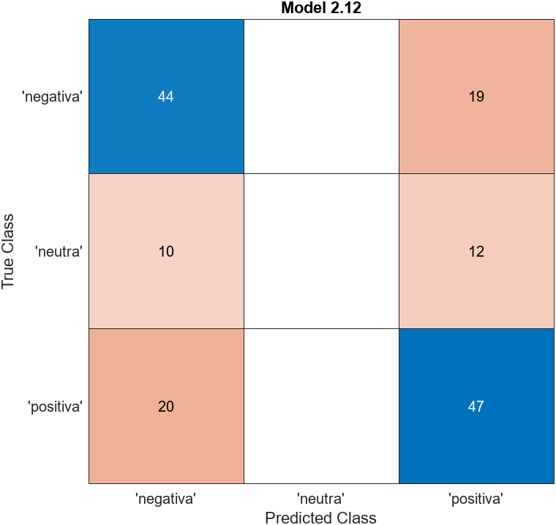

**Arousal: 2 categorie**

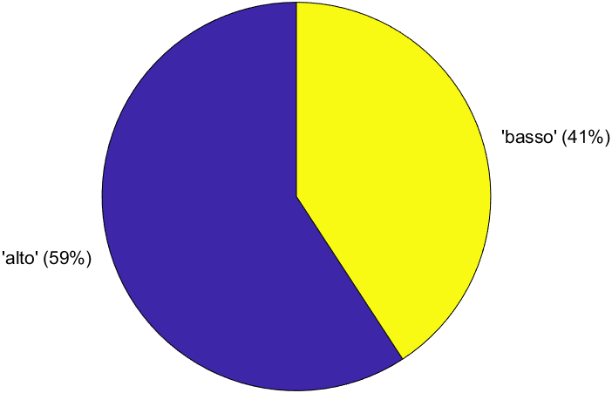 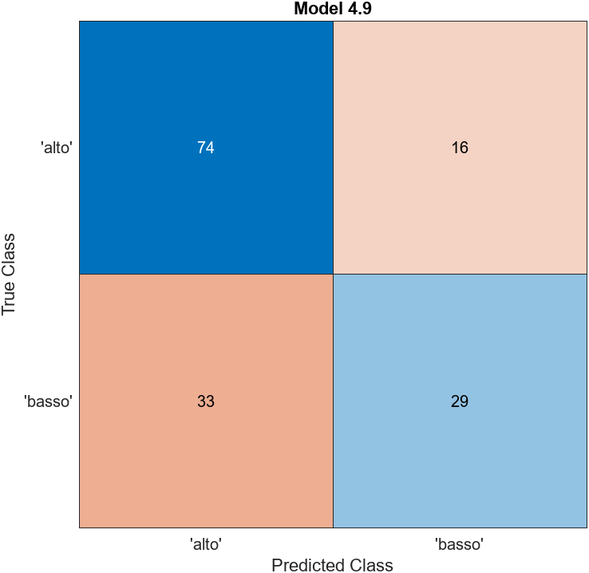

**Feature ranking (ANOVA)**

1. SF96_48 4.6810
2. SF192_96 4.5455
3. Colorfulness 3.0927
4. SF48_24 2.7502
5. SubbandEntropy 2.5726
6. SizeInBytes 2.3939
7. SF384_192 2.0170
8. SFresidual 1.8526
9. AverageLuminosity 1.2886
10. SF768_384 0.7918
11. FeatureCongestion 0.6669
12. SF24_12 0.3542
13. SF6_3 0.2659
14. Contrast 0.2283
15. SF12_6 0.2135

**Arousal: 3 categorie**

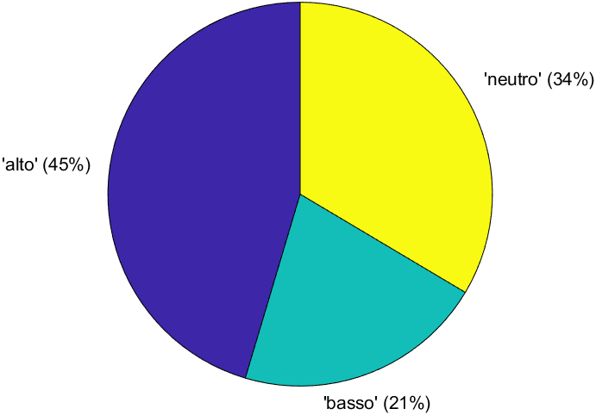 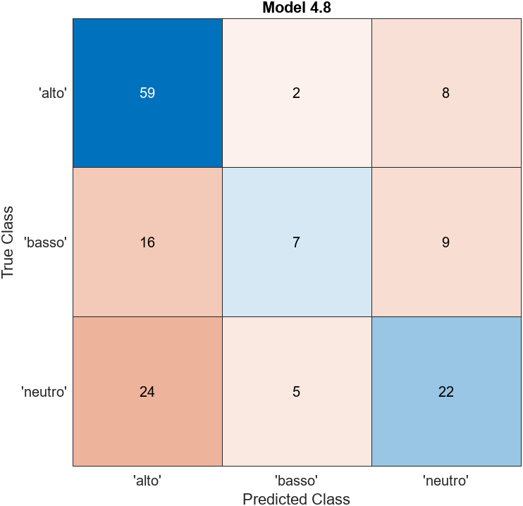

**Food**

|  |  |  |  |  |
| --- | --- | --- | --- | --- |
| food | | Accuratezza massima (%) e modello | | |
|  | **15 features** | | **10 features** | **5 features** |
| Valenza 2 cat. | 90,8 (SVM) | | 90,8 (KNN) | 89,9 (KNN, SVM,…) |
| *non normalized* | *89,9 (SVM)* | |  |  |
| Valenza 3 cat. | 75,2 (SVM) | | 70,6 (SVM, Kernel) | 67,9 (KNN) |
| Arousal 2 cat. | 77,1 (SVM) | | 77,1 (SVM, KNN, …) | 78,9 (KNN) |
| Arousal 3 cat. | 79,8 (SVM) | | 80,7 (KNN) | 80,7 (Kernel) |

**Valence: 2 categorie**

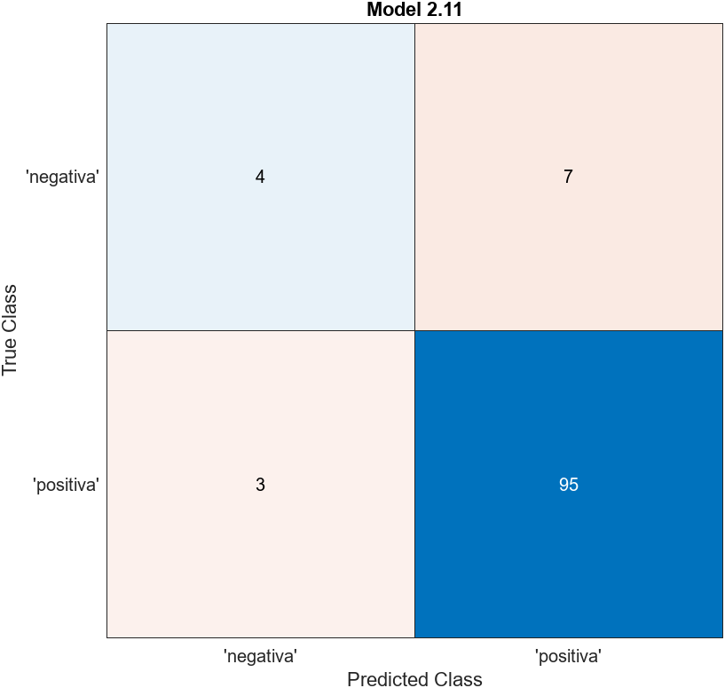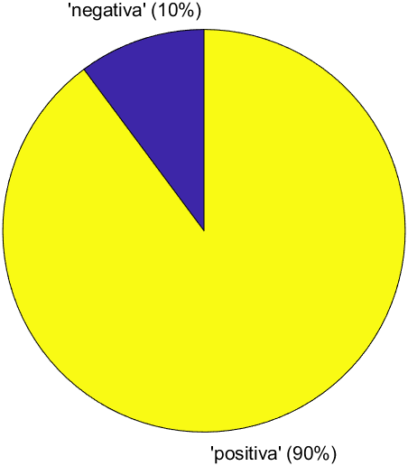

**Feature ranking (ANOVA)**

1. FeatureCongestion 2.6566
2. SF768_384 2.2617
3. SF12_6 2.1245
4. AverageLuminosity 2.0842
5. SF384_192 2.0396
6. SFresidual 1.8731
7. SF192_96 1.6416
8. SF48_24 1.6038
9. SF96_48 1.5031
10. SubbandEntropy 0.8210
11. Colorfulness 0.7212
12. Contrast 0.4415
13. SF24_12 0.4177
14. SizeInBytes 0.4083
15. SF6_3 0.3611

**Valence: 3 categorie**

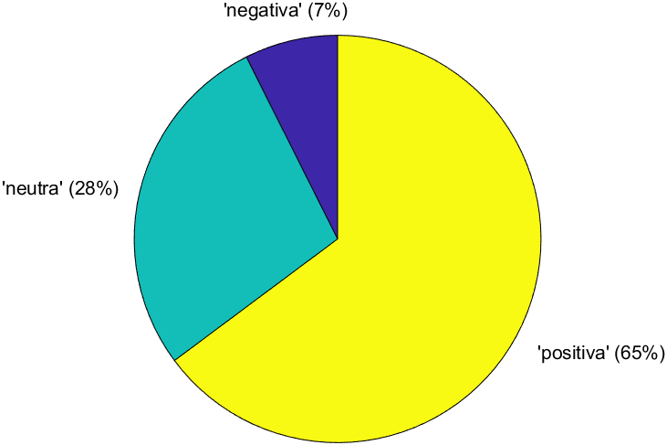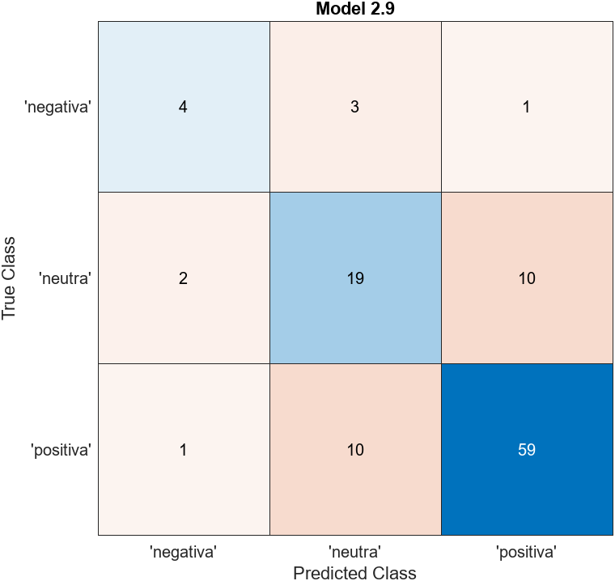

**Arousal: 2 categorie**

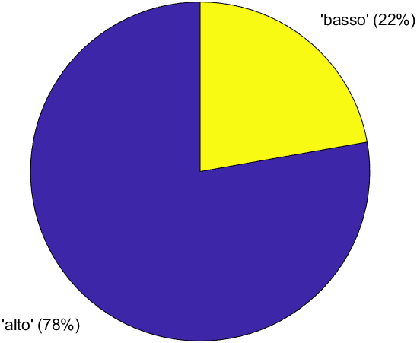 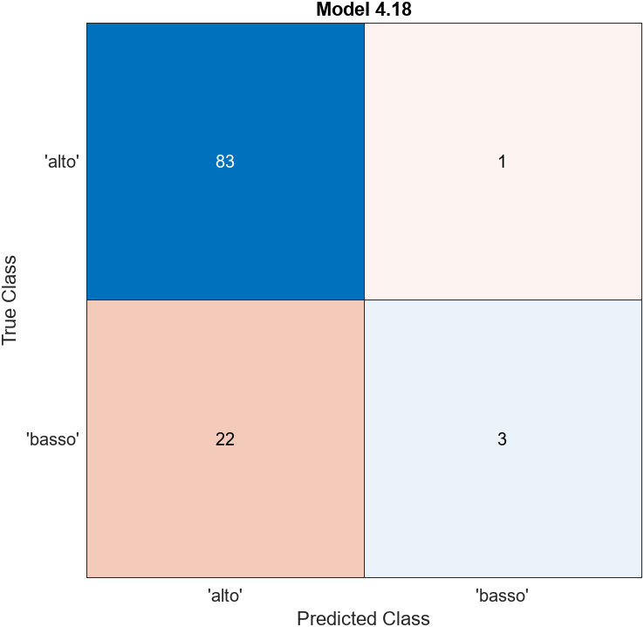

**Arousal: 3 categorie**

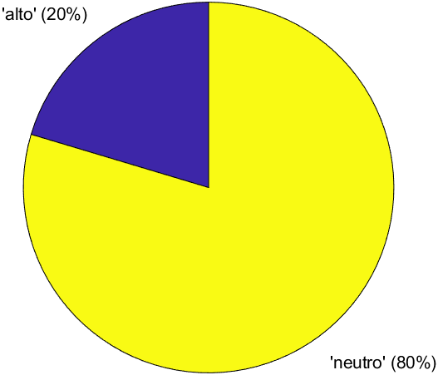 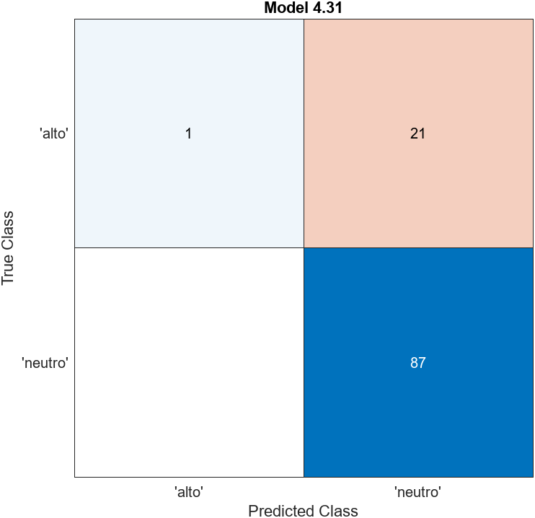

**Objects**

|  |  |  |  |  |
| --- | --- | --- | --- | --- |
| Objects | Accuratezza massima (%) e modello | | | |
|  | | **15 features** | **10 features** | **5 features** |
| Valenza 2 cat. | | 61,5 (SVM) | 59,4 (SVM) | 62,7 (NN) |
| *not normalized* | | *60,2 (SVM)* |  |  |
| Valenza 3 cat. | | 54,1 (Ensemble) | 50,8 (SVM, Kernel) | 52,0 (KNN) |
| Arousal 2 cat. | | 67,2 (SVM) | 63,9 (Ensemble) | 65,6 (SVM) |
| Arousal 3 cat. | | 63,5 (SVM) | 62,7 (SVM,KNN) | 63,5 (SVM) |

**Valence: 2 categorie**

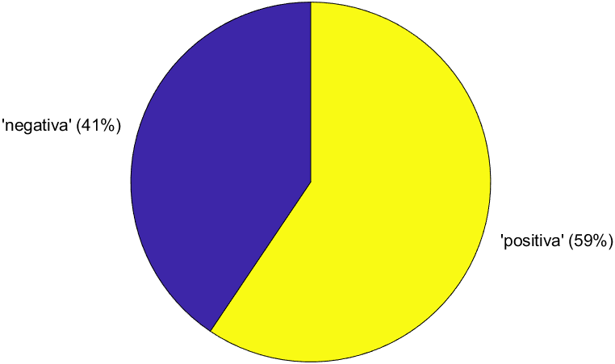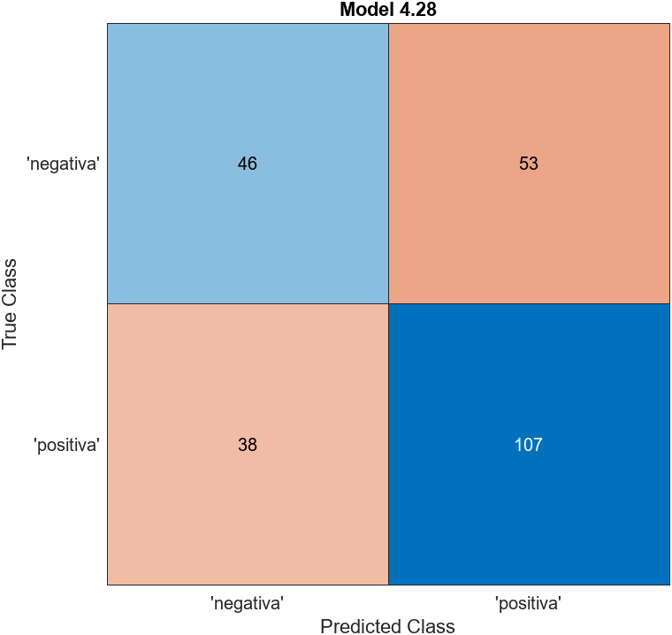

**Feature ranking (ANOVA)**

1. Contrast 4.3980
2. Colorfulness 2.0688
3. SF6_3 1.8380
4. SF48_24 1.80341
5. SF12_6 1.7713
6. AverageLuminosity 1.2171
7. SFresidual 1.0421
8. SF96_48 0.8338
9. SF192_96 0.5901
10. SizeInBytes 0.4016
11. SF24_12 0.3224
12. FeatureCongestion 0.2081
13. SF768_384 0.1996
14. SubbandEntropy 0.1137
15. SF384_192 0.0936

**Valence: 3 categorie**

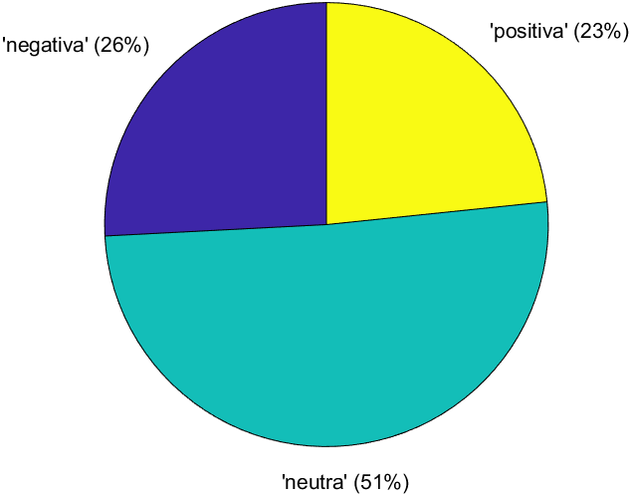 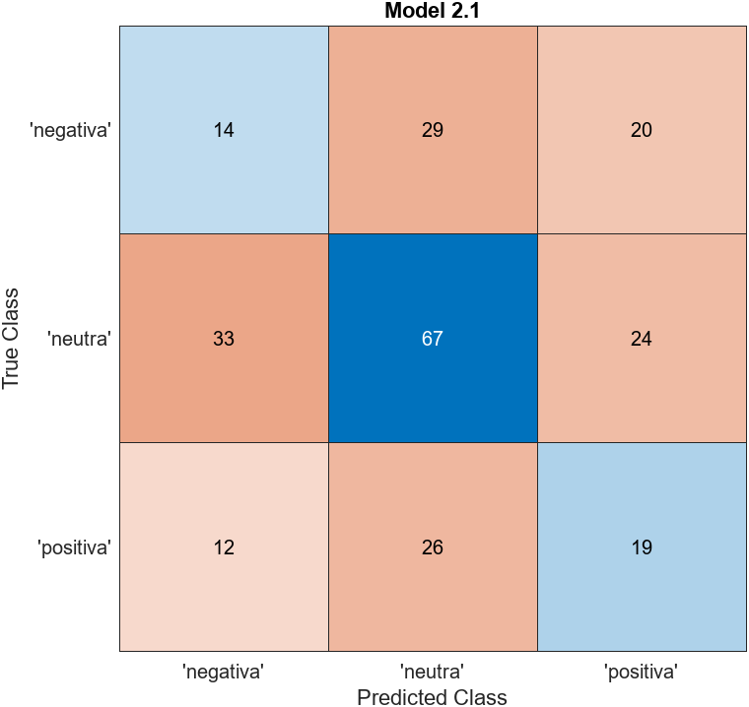

**Arousal: 2 categorie**

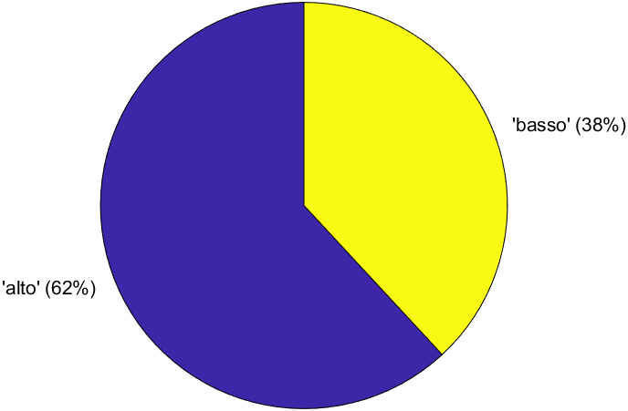 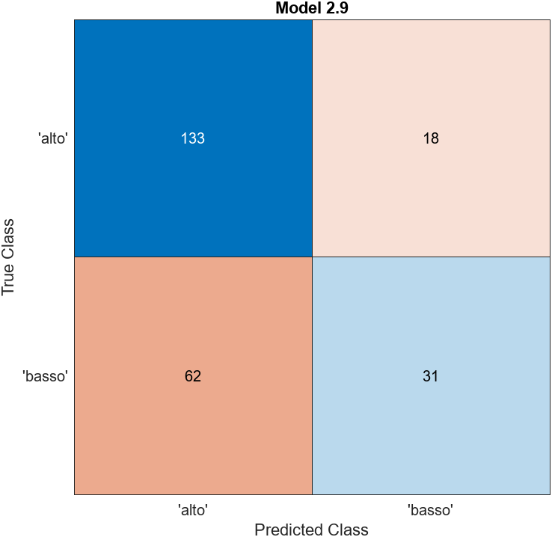

**Feature ranking (ANOVA)**

1. SF48_24 5.3860
2. SF96_48 5.2468
3. AverageLuminosity 3.9921
4. SFresidual 3.9273
5. SF24_12 3.8560
6. SF192_96 3.6796
7. SubbandEntropy 1.7728
8. FeatureCongestion 0.8522
9. Colorfulness 0.6761
10. SF6_3 0.6640
11. SF384_192 0.4095
12. SF768_384 0.3778
13. Contrast 0.0395
14. SF12_6 0.0328
15. SizeInBytes 0.0248

**Arousal: 3 categorie**

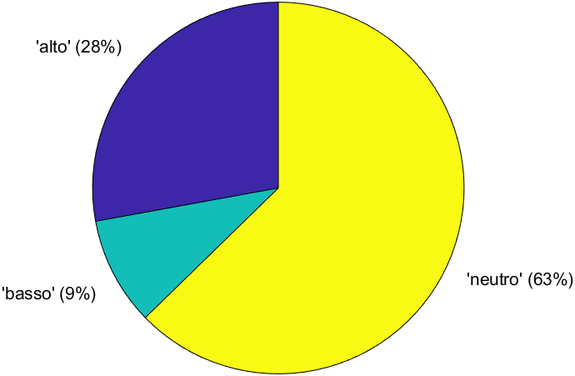 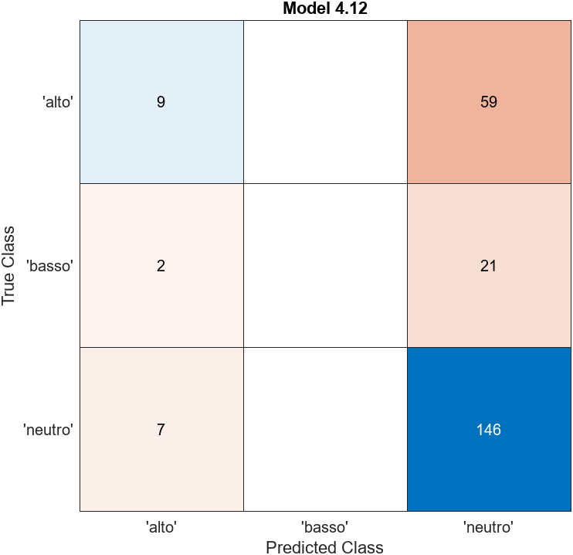

**Landscapes**

|  |  |  |  |  |
| --- | --- | --- | --- | --- |
| Landscapes | Accuratezza massima (%) e modello | | | |
|  | | **15 features** | **10 features** | **5 features** |
| Valenza 2 cat. | | 78,3 (SVM, Kernel) | 79,8(SVM) | 78,8 (SVM) |
| *non normalized* | | *79,8 (Quadr. Discr.)* |  |  |
| Valenza 3 cat. | | 68,2 (SVM) | 69,2 (SVM, Kernel) | 67,2(KNN) |
| Arousal 2 cat. | | 72,2 (Ensemble) | 70,7 (SVM, Lin.Discr.) | 67,7 (Naive Bayes) |
| Arousal 3 cat. | | 55,1 (SVM) | 56,1 (Bagged Trees) | 49,5 (Ensemble) |

**Valence: 2 categorie**

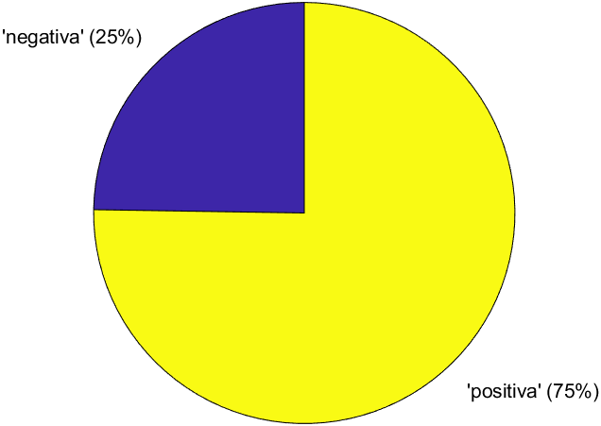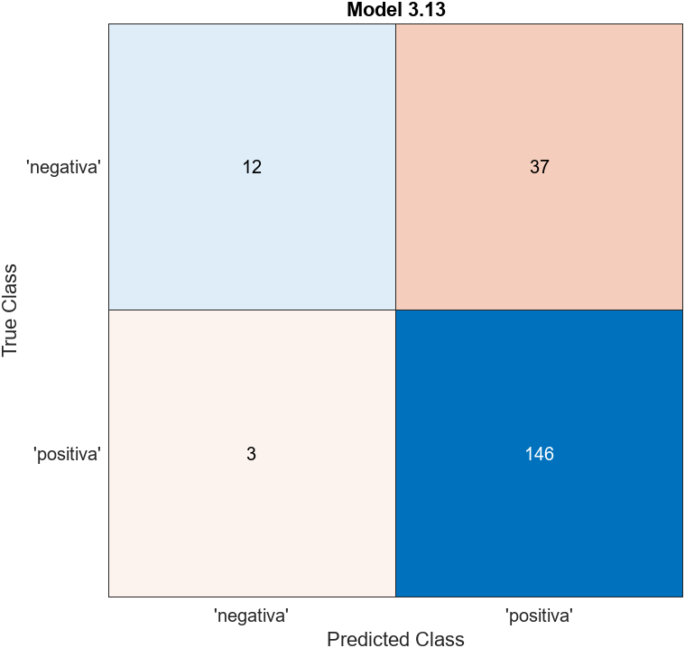

**Feature ranking (ANOVA)**

1. Colorfulness 11.5233
2. SF12_6 9.5115
3. SF24_12 8.3360
4. SF48_24 5.2035
5. SF96_48 3.3683
6. SFresidual 2.5914
7. SF192_96 2.3212
8. SF6_3 2.2076
9. AverageLuminosity 1.9977
10. Contrast 1.5922
11. SF384_192 1.0235
12. FeatureCongestion 0.9091
13. SubbandEntropy 0.8940
14. SizeInBytes 0.6292
15. SF768_384 0.5840

**Valence: 3 categorie**

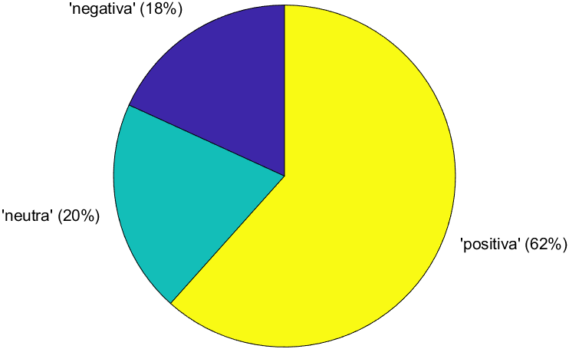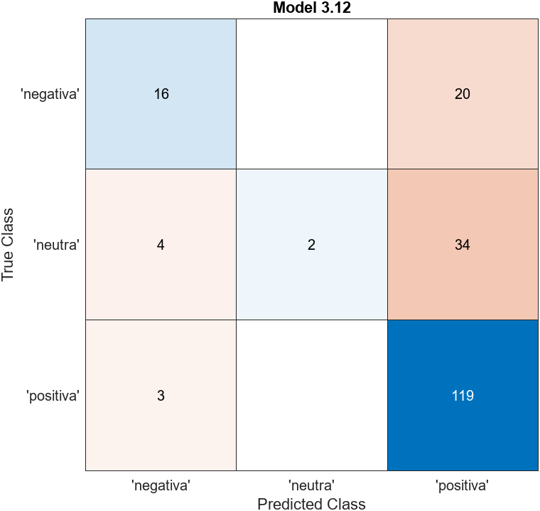

**Arousal: 2 categorie**

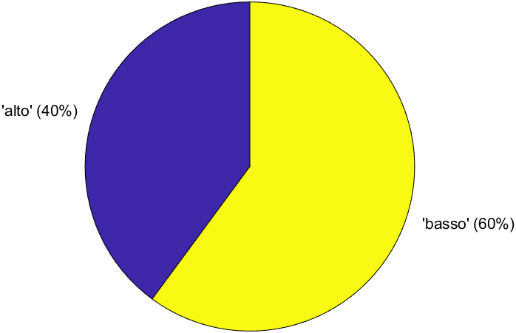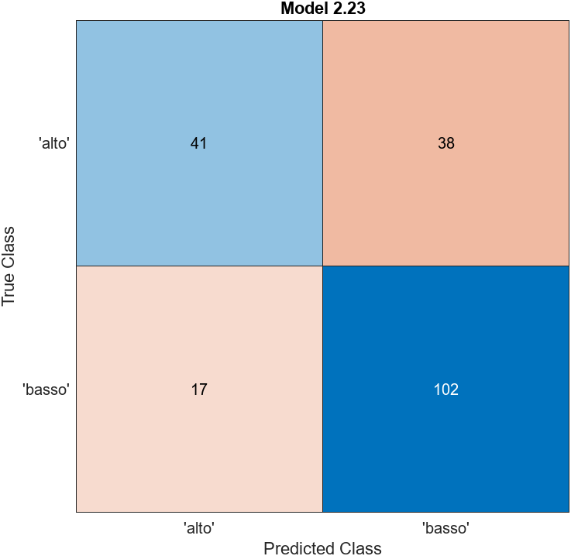

**Feature ranking (ANOVA)**

1. SF48_24 19.0210
2. SF96_48 18.7615
3. SF192_96 15.3563
4. SF24_12 13.6339
5. FeatureCongestion 7.9202
6. SF384_192 6.9106
7. SF12_6 6.7085
8. SFresidual 5.8178
9. AverageLuminosity 4.7090
10. Contrast 3.6688
11. SF6_3 1.7327
12. SF768_384 1.6630
13. Colorfulness 1.4745
14. SubbandEntropy 0.8728
15. SizeInBytes 0.1508

**Arousal: 3 categorie**

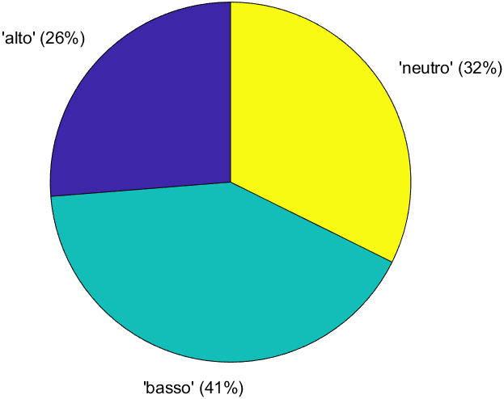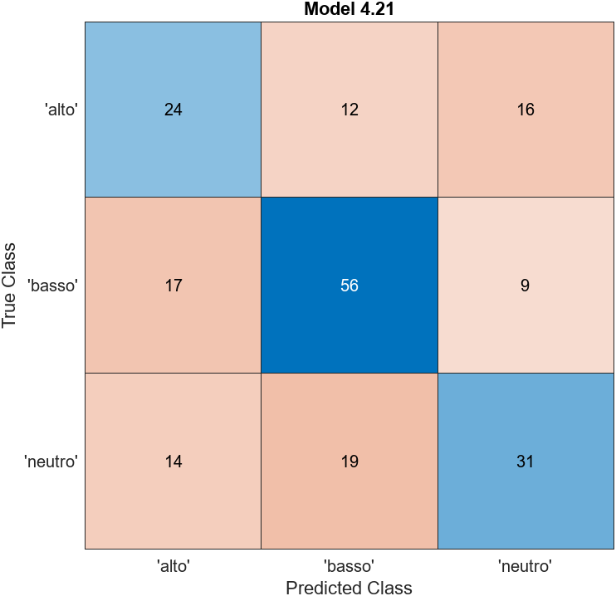

**People**

|  |  |  |  |  |
| --- | --- | --- | --- | --- |
| People | Accuratezza massima (%) e modello | | | |
|  | | **15 features** | **10 features** | **5 features** |
| Valenza 2 cat. | | 70,0(Kernel) | 70,7(Ensemble) | 70,0 (Ensemble) |
| *non normalized* | | *72,9 (Ensemble)* |  |  |
| Valenza 3 cat. | | 63,4 (KNN) | 60,6 (SVM) | 59,0 (SVM) |
| Arousal 2 cat. | | 77,6 (Ensemble) | 75,4 (Ensemble) | 76,7 (Ensemble) |
| Arousal 3 cat. | | 61,2(KNN) | 57,4 (SVM) | 59,3 (Naïve Bayes) |

**Valence: 2 categorie**

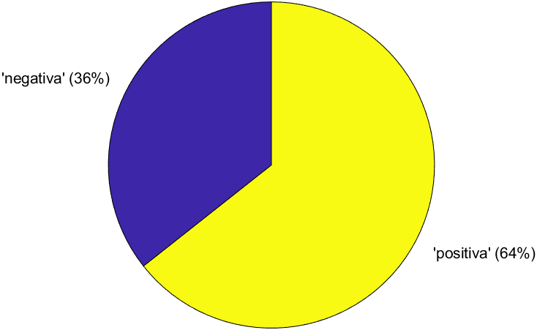 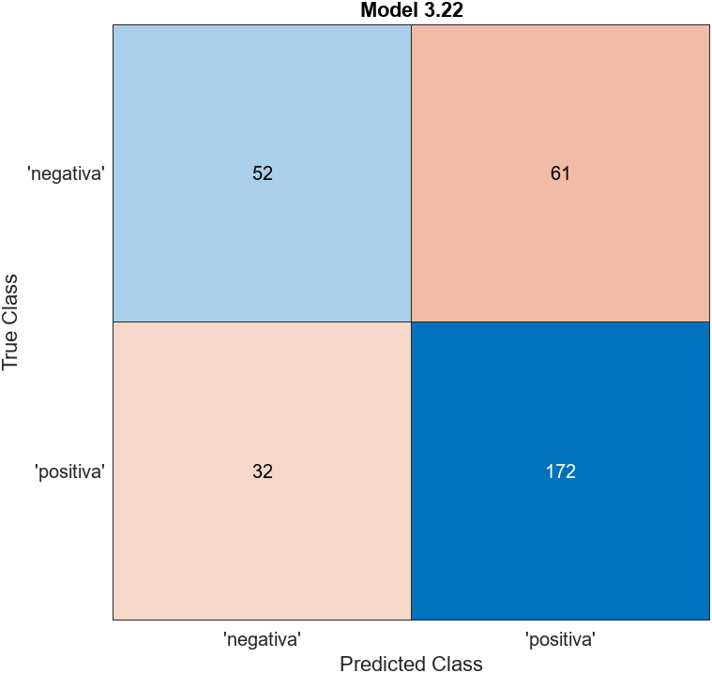

**Feature ranking (ANOVA)**

1. FeatureCongestion 15.5986
2. SizeInBytes 15.3186
3. SubbandEntropy 10.7848
4. SF768_384 8.5609
5. SF384_192 7.9626
6. SF192_96 7.1149
7. SF96_48 6.3492
8. Colorfulness 5.4283
9. AverageLuminosity 4.6796
10. SF48_24 3.9719
11. SF6_3 3.9378
12. SF24_12 2.8558
13. SFresidual 2.7921
14. Contrast 0.3906
15. SF12_6 0.1311

**Valence: 3 categorie**

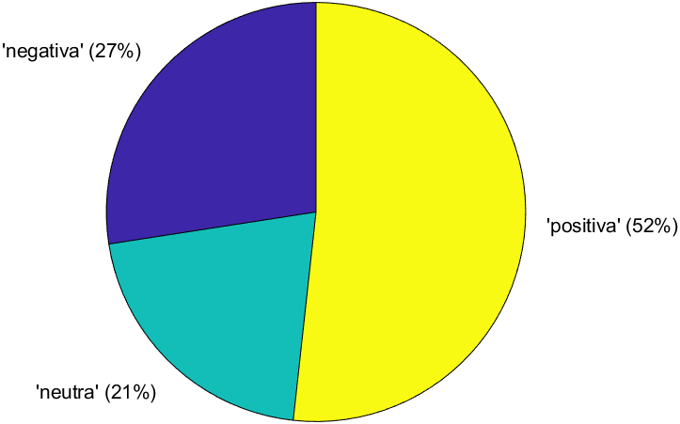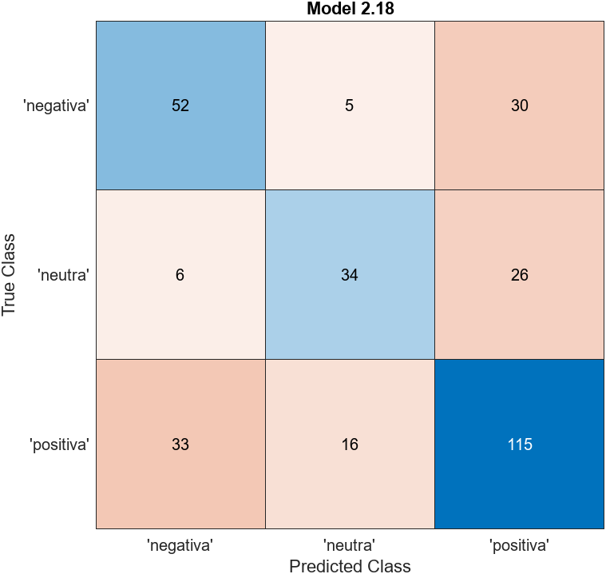

**Arousal: 2 categorie**

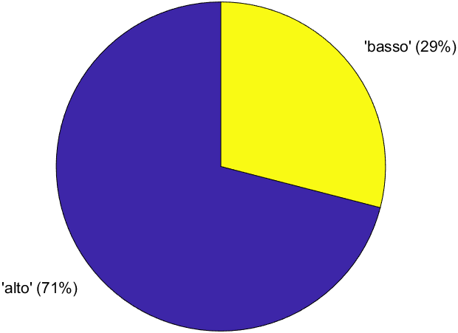 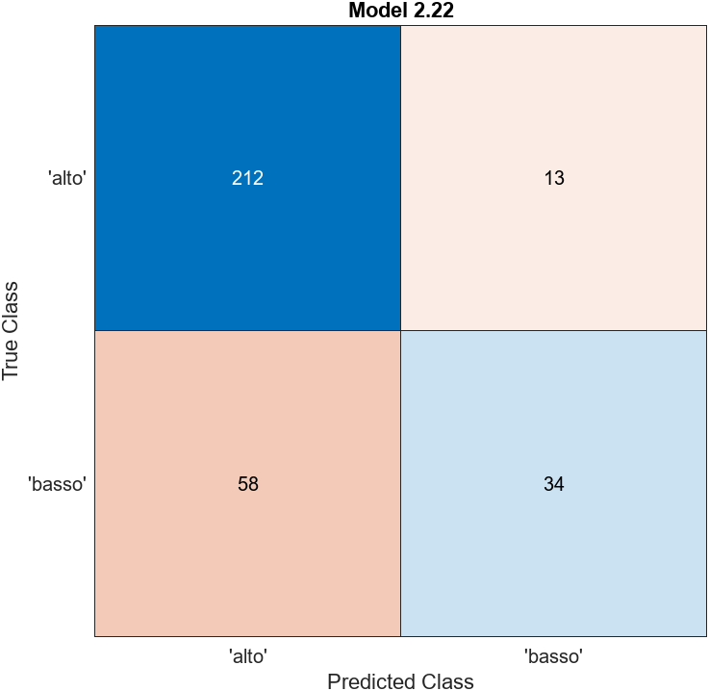

**Feature ranking (ANOVA)**

1. SubbandEntropy 24.3526
2. FeatureCongestion 21.2110
3. SF768_384 18.4129
4. SizeInBytes 16.8706
5. SF384_192 13.2722
6. AverageLuminosity 10.2642
7. SFresidual 9.0856
8. SF192_96 6.3478
9. SF96_48 3.3183
10. Colorfulness 1.3457
11. SF48_24 1.1935
12. Contrast 1.1347
13. SF12_6 0.2604
14. SF6_3 0.1779
15. SF24_12 0.1500

**Arousal: 3 categorie**

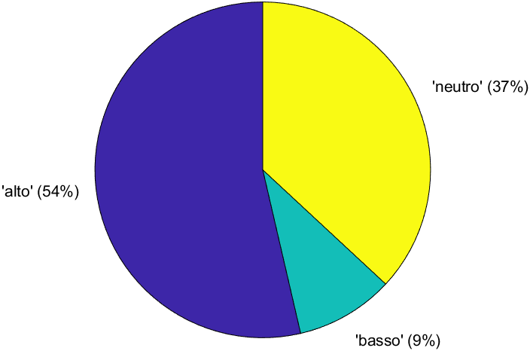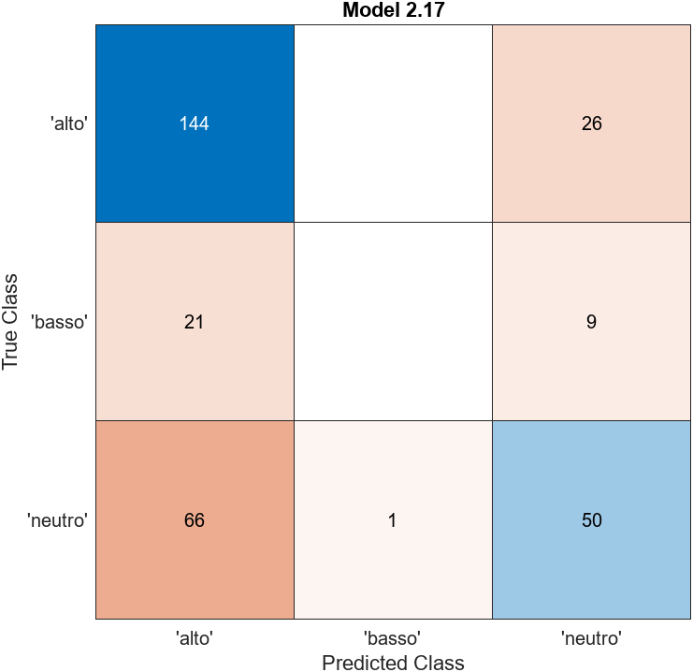

**Sports**

|  |  |  |  |  |
| --- | --- | --- | --- | --- |
| Sports | Accuratezza massima (%) e modello | | | |
|  | | **15 features** | **10 features** | **5 features** |
| Valenza 2 cat. | | 96,0 (NN) | 96,0 (NN) | 96,0 (Naive Bayes) |
| *non normalized* | | *96,0 (NN, KNN,..)* |  |  |
| Valenza 3 cat. | | 84,0 (SVM, KNN, …) | 84,0 (SVM, KNN, …) | 84,0 (KNN, Kernel) |
| Arousal 2 cat. | | n.c. | n.c. | n.c. |
| Arousal 3 cat. | | 96,0 (NN, KNN, …) | 96,0 (NN, KNN, …) | 96,0 (NN, KNN, …) |

**Valence: 2 categorie**

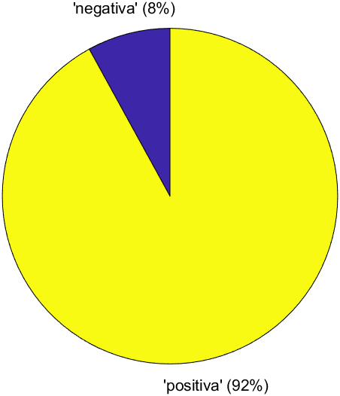 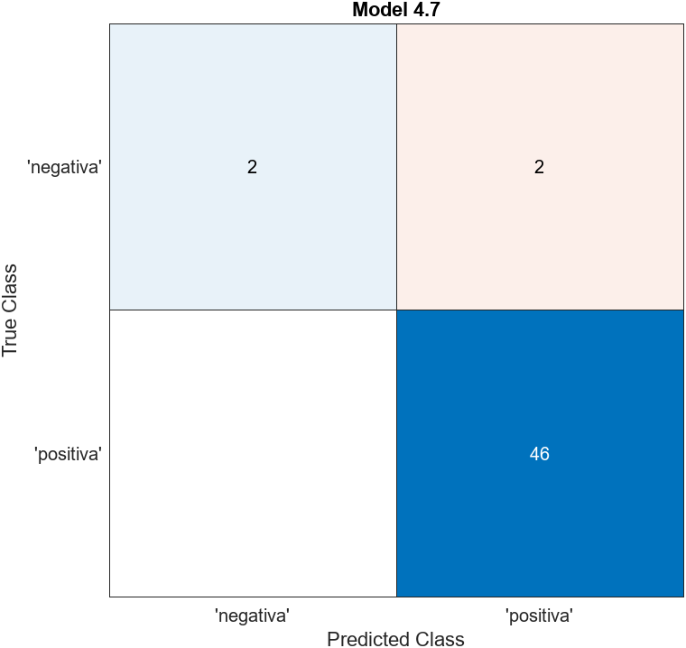

**Feature ranking (ANOVA)**

1. SF24_12 5.5523
2. SF6_3 4.9749
3. AverageLuminosity 4.9461
4. SF384_192 4.0600
5. SFresidual 3.8632
6. SF48_24 2.8451
7. SF192_96 2.8382
8. SF96_48 2.7564
9. SizeInBytes 2.3316
10. SF768_384 2.3132
11. Contrast 1.8063
12. Colorfulness 1.7913
13. SF12_6 1.0578
14. FeatureCongestion 0.4420
15. SubbandEntropy 0.0166

**Valence: 3 categorie**

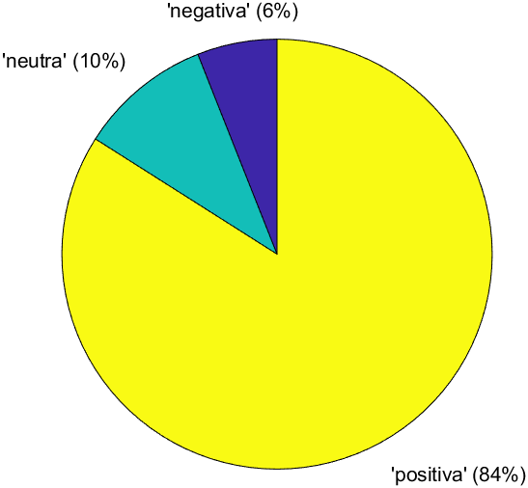 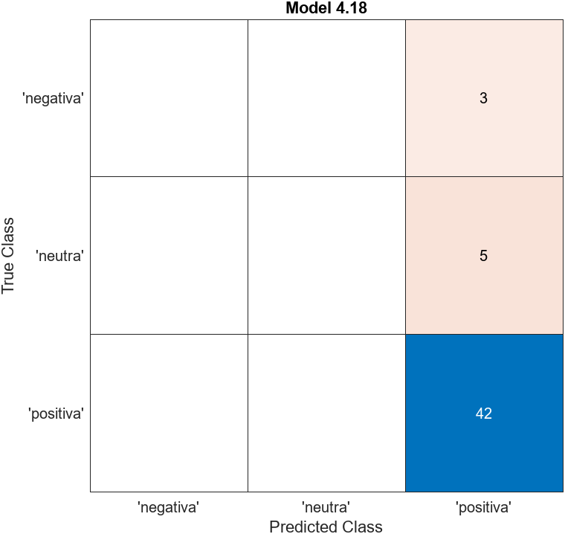

**Arousal: 2 categorie**

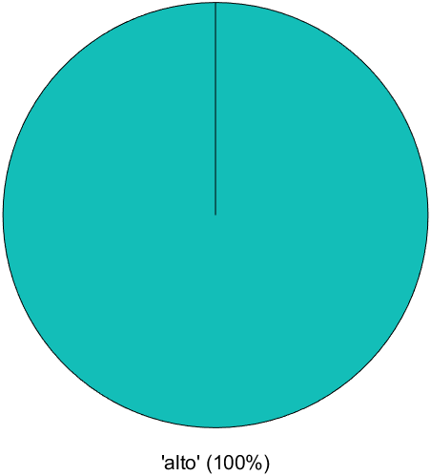

**Arousal: 3 categorie**

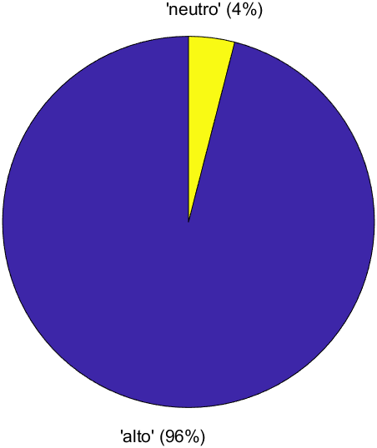 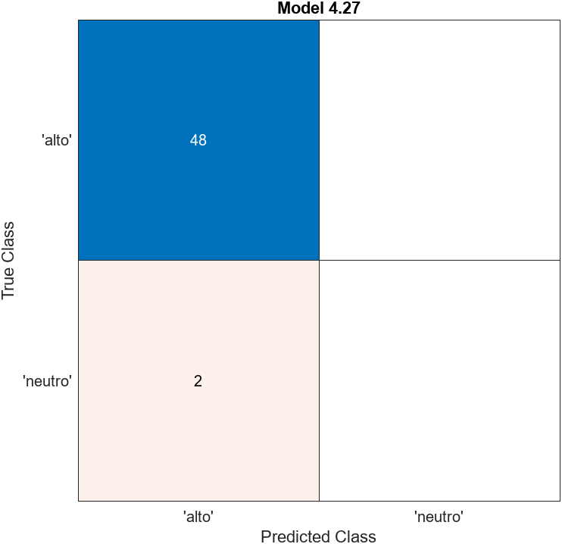

**Feature ranking (ANOVA)**

1. SF48_24 1.8182
2. SF96_48 1.7379
3. SF24_12 1.6137
4. SF192_96 1.5415
5. SFresidual 1.0769
6. SF12_6 0.8593
7. AverageLuminosity 0.8003
8. SF768_384 0.7752
9. FeatureCongestion 0.5369
10. SF6_3 0.3258
11. Contrast 0.2324
12. SF384_192 0.0765
13. SizeInBytes 0.0675
14. SubbandEntropy 0.0457
15. Colorfulness 0.0420